ORGANISING COMMITTEE

Grigoriev A.Y. - Chairman
Myshkin N.K. - Deputy Chairman
Podgornaya V.V. - Deputy Chairman
Kavaliova I.N. - Executive Secretary

Detailed information about the members of the Organising and Scientific-Program Committees will be placed in the Second information message and on the website http://mpri.org.by.

CONFERENCE ORGANISER

V.A. Belyi Metal-Polymer Research Institute of National Academy of Sciences of Belarus.

SECRETARY

Tel: +375 (232) 340636 – Kavaliova Inna N.
Fax: +375 (232) 341712
E-mail: polycomtrib24@mpri.org.by
Web-site: http://mpri.org.by

PLACE OF CONDUCT / Location of Conference
The Conference will be conducted by the V.A. Belyi Metal-Polymer Research Institute of National Academy of Sciences of Belarus in the Gomel (Belarus) from 25 to 28 June 2024.

PRESENTATION OF MATERIALS
Each participant cann’t present more than 2 papers. For participation in the conference it is necessary to send by 20.05.2024 by e-mail polycom-trib24@mpri.org.by to the address of the Organising Committee: registration card; abstracts of the report; expert opinion on the possibility of publication in the open press. It is also necessary to provide the phone number and e-mail of the author responsible for correspondence. Faxed materials will not be accepted.

ABSTRACTS DESIGN RULES
The volume of abstract is 1 page. The electronic template of abstracts is available at http://mpri.org.by in the section "Conferences".
Author(s) should indicate the title of the report, initials and surname of the author(s), organization(s), city, country in the title of the text. Abstract should contain the statement of the problem, methods of research, obtained results, conclusions. The Organising Committee reserves the right of editorial revision of materials and rejection of materials that do not correspond to the subjects of the conference.
Abstracts will be published in the language of submission by the opening of the conference. The full texts of the reports can be published in the journals «Friction and Wear» (presented in RSCI - Russian version of the journal ISSN 0202-4977, SCOPUS - English version of the journal ISSN 1068-3666) and «Polymer Materials and Technologies» (ISSN 2415-7260) upon the recommendation of the Organising Committee after reviewing and editing.

ACCOMMODATION
Conference accommodation options will be announced in the Second Information Message and on the conference website.

MAIN DATES
Submission of materials deadline ............... 20.05.2024.
Payment of the organisation fee deadline.... 15.06.2024.
Application for hotel reservation deadline ...15.06.2024.
Mailing of the conference program deadline ... 20.06.2024.

National Academy of Sciences of Belarus
Belarusian Republican Foundation for Fundamental Research
V.A. Belyi Metal-Polymer Research Institute of National Academy of Sciences of Belarus

International Scientific and Technical Conference «Polymer Composites and Tribology»
POLYCOMTRIB-2024

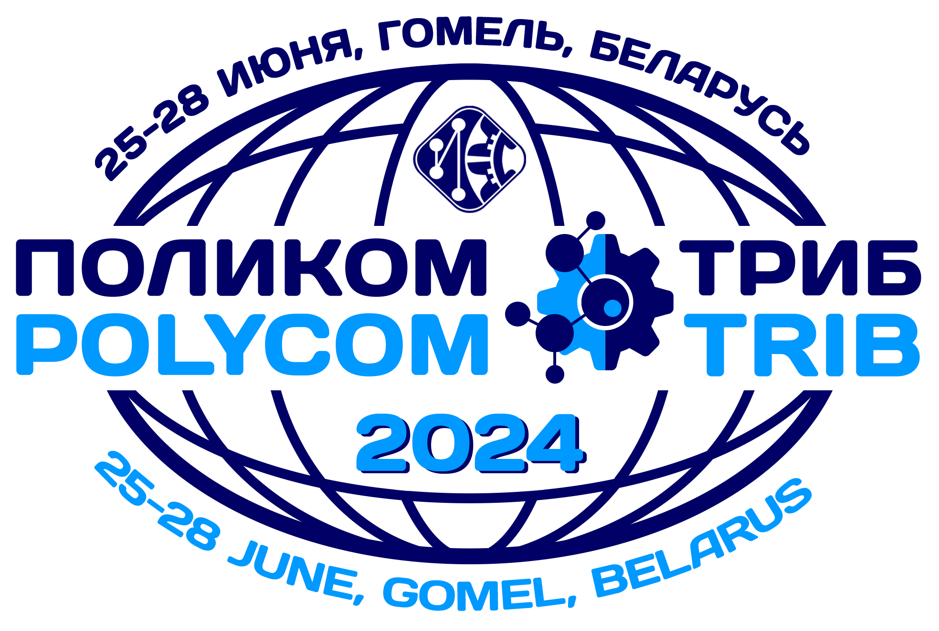

First information message

25 - 28 June 2024
GOMEL, BELARUS

THEMATICS of Conference

- physico-chemical bases of polymer composites creation and interphase interaction of components;
- structure and properties of polymer composites, methods of control, analysis, diagnostics, determination of operational durability;
- technologies of obtaining, calculation, design and efficiency of application of products from polymer composites;
- resource-saving and environmentally friendly technologies in materials science;
- friction material science;
- triboanalysis (development of the theory of friction, wear and lubrication of solid bodies);
- tribo-material science (study and management of properties of materials of moving interfaces; new lubricants and additives);
- tribotechnics (technical means, friction units, methods of their calculation and design), test methods and diagnostics.
- medical and biological aspects of polymer composites application;
- nanostructure systems, nanomaterials and nanotechnologies;
- fluoropolymers: technologies, research, application;
- mechanics of polymer composites and modelling;
- physics, chemistry and mechanics of surfaces, coating and film technologies.

REGULAMENT
- plenary reports - up to 20 minutes;
- oral reports - up to 10 minutes;
- poster presentations - A1 sheet.

The official languages of the Conference are
Russian and English

PAYMENT

Participants (with or without report) should send the registration form (till 20.05.2024) and should pay (till 15.06.2024) the organisational fee for each participant.
For the conference fee payment by bank transfer, organisations should fill in the contract, invoice and certificate of work performed (download documents at http://mpri.org.by), send them to polycomtrib24@mpri.org.by and bring the original documents (2 copies with stamps) to the conference.
The electronic materials will be sent by the organizers by mail to the absentee participants who have paid the organising fee. For this it is necessary to get the postal address for sending to the Organising Committee together with the receipt of payment for publication.

Information about the amount of the Organising Fee and settlement accounts for transferring the Organising Fee will be placed in the Second information message. Sample contracts for conference participants will be published on the website http://mpri.org.by in the section "Conferences" until 1 March 2024.

Form of the conference - full-time and correspondence courses

REGISTRATION CARD
International Scientific and Technical Conference
«Polymer composites and tribology»
POLYCOMTRIB-2024

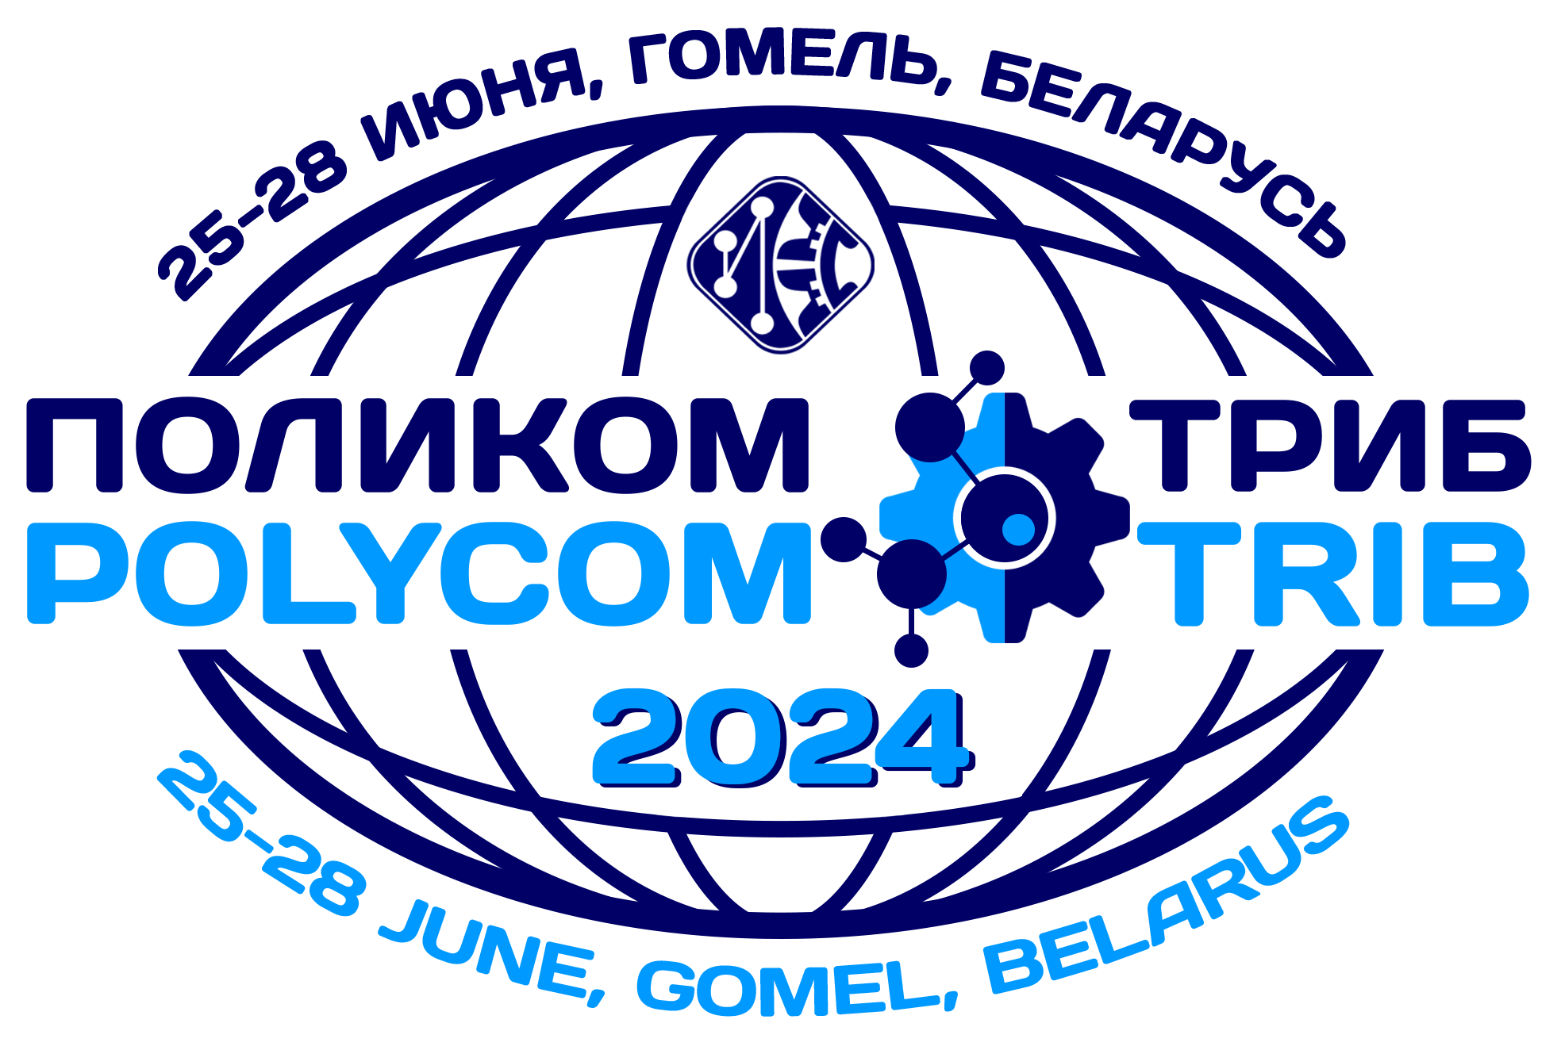 | 25-28 June 2024  Gomel, Belarus

First name ____________________________________
Surname ____________________________________
Position of the participant ____________________________
Degrees ____________________________________
Organisation ____________________________________
____________________________________________________
(full name)
Address ____________________________________________
Tel/fax ________________________________________
E-mail _____________________________________________
Title of the report _____________________________________
_____________________________________________________
Author for correspondence Surname________________________
Tel ________________________ e-mail __________________
Form of participation (tick):
full-time ⁯ with report ⁯
absentee ⁯ without report ⁯

Form of the report (tick):
oral ⁯ poster presentation ⁯

Accommodation *:
1-bed room
2-bed room
Name of companion/companion _______________
without accommodation
*- hotel information and booking request form will be posted on http://mpri.org.by

